Food Management System

Third Sprint!

Roshini Seelamsetty, Nida Tazeen

Purdue University

ACS 560: Software Engineering

Matthew Parker

Nov 18, 2024

During Sprint 3, significant improvements were made to the UPDATE functionality of our system. Initially, the feature had limitations that hindered its usability. After a thorough review, we restructured the logic to enhance its flexibility and reliability.

The updated UPDATE functionality now allows for partial updates. The only mandatory field is the Order ID, which serves as a unique identifier to locate the specific record. All other fields are optional, meaning users can update one or more fields without the need to provide values for every attribute in the record. This change significantly improves efficiency, particularly in cases where only a subset of the order data requires modification.

Additionally, we introduced a new feature: Order History Retrieval by Customer ID. This functionality enables users to fetch the complete order history of a specific customer using their Customer ID. It provides a comprehensive view of all past transactions, which is invaluable for both customer service and analytical purposes. This enhancement supports better decision-making by giving insights into customer behavior and order trends.

Other functionality we added is filtering orders using a minimum and maximum value for ratings.

Screenshots:

The below 2 screenshots shows the Customer Order History-

The below 2 screenshots shows the UPDATE functionality-

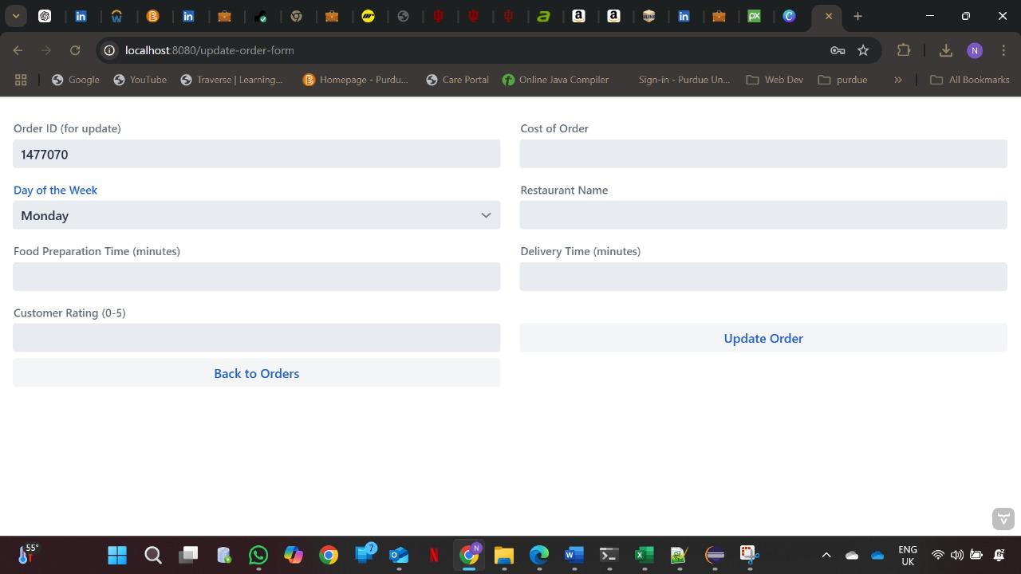

The below screenshot shows the filtering orders functionality –

The below screenshot shows the completion of Sprint 3 -

Git Repository - <https://github.com/tazeenida/Food-Management-System>